Find the missed words using the tips.

Who’s your Mama’s Mama?
She’s my _____
Who’s your Daddy’s Mama?
She’s my_______, too
______, ______, I love you.
Who’s your Mama’s Daddy?
He’s my ______
Who’s your Daddy’s Daddy?
He’s my_______, too
Grandpa, Grandpa, I love you.
Chorus:
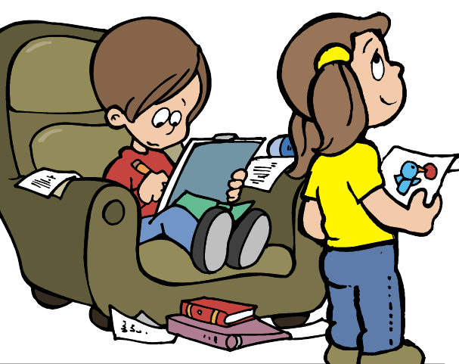
Lucky to be in the family
I belong to you, and you belong to me
Who’s your Mama’s sister?
She’s my _______
Who’s your Daddy’s sister?
She’s my______, too
_____, _______, I love you.
Who’s your Mama’s brother?
He’s my _____
Who’s your Daddy’s brother?
He’s my______, too
______, _______, I love you.
(Chorus)
Who’s your Mama’s sister’s children?
They’re my _______
Who’s your Daddy’s sister’s children?
They’re my________, too
_____, _______, I love you.

Who’s your Mama’s brother’s children?
They’re my______.
Who’s your Daddy’s brother’s children?
They’re my_______, too
_____, _______, I love you.

(Chorus)
Who is my true family? Everybody!
Everyone and everywhere, every color, too
Family, Family, I love you.
(Chorus)
