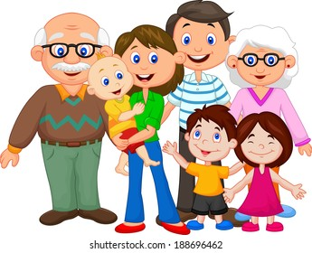

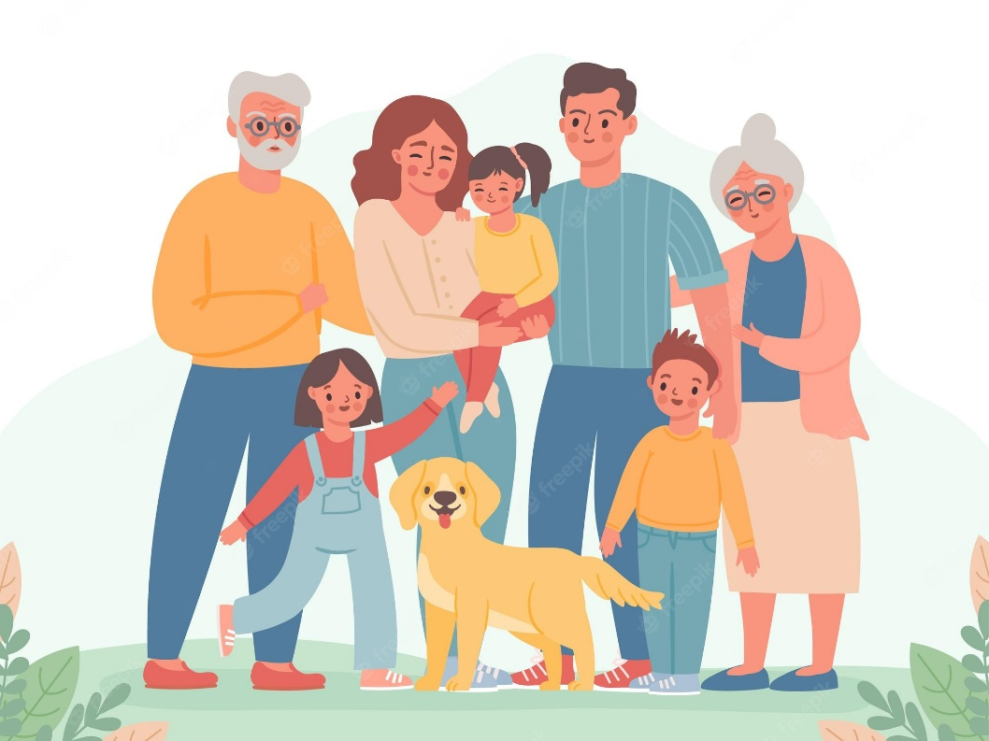
I live in a ….. small family/ big family/ nuclear family:

extended family,
nuclear family2 chlidren two parents
patchwork family
relative(s)

FAMILY MEMBERS

Masculine | Feminine
father | mother
son | daughter
brother | sister
husband | wife
When you have children, you are a parent.
If you are a male parent, you are a father.
If you are female parent, you are a mother.
If one of your children is a boy, he is your son.
If one of your children is a girl, she is your daughter.
When a couple gets married, the man is the husband, and the woman is his wife.
A brother and sister both have the same parents.
One collective word to describe brothers and sisters is siblings.

Different Generations
Great-great grandfather | Great-great grandmother
Great grandfather | Great grandmother
Grandfather | Grandmother
Father | Mother
Son | Daughter
Grandson | Granddaughter
Great grandson | Great granddaughter
Great-great grandson | Great-great granddaughter
Descendents

Relatives and Extended Family
grandparents: the parents of your parents
grandfather: the father of your father/mother
grandmother: the mother of your father/mother
grandchildren: the children of your children
grandson: the son of one of your children
granddaughter:the daughter of one of your children
great grandfather: the father of your grandfather/grandmother
great grandmother: the mother of your grandfather/grandmother
uncle: the brother (or brother-in-law) of your mother/father
aunt: the sister (or sister-in-law)of your mother/father
cousin: the child of your aunt/uncle
nephew: the male child of your brother/sister
niece: the female child of your brother/sister

The In-Laws
The in-laws are the members of the family of your spouse (the person you are married to) or via a marriage in your family:
father-in-law: the father of your spouse
mother-in-law: the mother of your spouse
son-in-law: the husband of your daughter
daughter-in-law: the wife of your son
brother-in-law: the husband of your sister

The Family Mix
"Step-" means that you are related as a result of one parent marrying again
stepfather: the (new) husband of your mother but not your biological father
stepmother: the (new) wife of your father but not your biological mother
stepson: the son of your (new) husband / wife (he is not your biological son)
stepdaughter: the daughter of your (new) husband / wife (she is not your biological daughter)
stepsister: the daughter of your stepmother or stepfather
stepbrother: the son of your stepmother or stepfather
Sometimes one of your parents gets married again and they have more children. There
half-brother: the brother you have only one parent in common with .
half-sister: the sister you only have one parent in common with.

Appearance
attractive, good- looking, sporty, handsome, pretty
Be igéval
height : tall, medium-height, short
Weight : slim/ tin, medium height, chubby, overweight, obese
age: child, young, teenager, young adult, middle-aged, old, elderly
frickled, wrinkled

have got/ has got
hair: brown, blonde, black , red, straight, wavy, curly, long, sholder lenght, sort, bald
eyes: brown, blue, green.
face: oval shaped, roundish
moustache, beard

Personality:
kind unkind
polite impolite
hard wroking lazy
serious easy-going
generous selfish
talkative/ chaty shy
friendly unfriendly
funny
wise
clever
brave
neat
sociable

